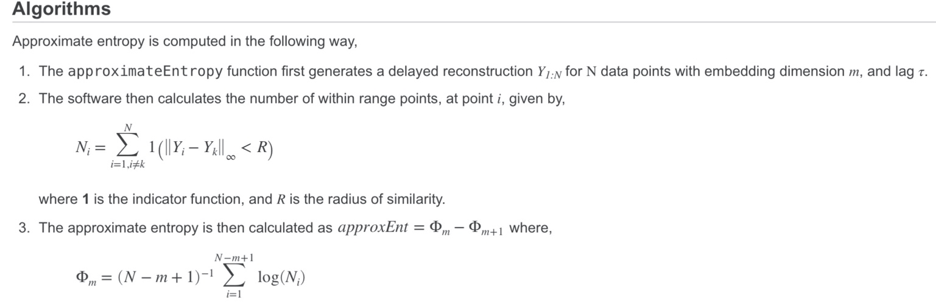**（1）Approximate Entropy algorithms：**

**（2）Approximate Entropy from MATLAB Community:**

function [apen] = approx_entropy(n,r,a)

%% Code for computing approximate entropy for a time series: Approximate

% Entropy is a measure of complexity. It quantifies the unpredictability of

% fluctuations in a time series

% To run this function- type: approx_entropy('window length','similarity measure','data set')

% i.e approx_entropy(5,0.5,a)

% window length= length of the window, which should be considered in each iteration

% similarity measure = measure of distance between the elements

% data set = data vector

% small values of apen (approx entropy) means data is predictable, whereas

% higher values mean that data is unpredictable

% concept boorowed from http://www.physionet.org/physiotools/ApEn/

% Author: Avinash Parnandi, parnandi@usc.edu, http://robotics.usc.edu/~parnandi/

%%

data =a;

for m=n:n+1; % run it twice, with window size differing by 1

set = 0;

count = 0;

counter = 0;

window_correlation = zeros(1,(length(data)-m+1));

for i=1:(length(data))-m+1,

current_window = data(i:i+m-1); % current window stores the sequence to be compared with other sequences

for j=1:length(data)-m+1,

sliding_window = data(j:j+m-1); % get a window for comparision with the current_window

% compare two windows, element by element

% can also use some kind of norm measure; that will perform better

for k=1:m,

if((abs(current_window(k)-sliding_window(k))>r) && set == 0)

set = 1; % i.e. the difference between the two sequence is greater than the given value

end

end

if(set==0)

count = count+1; % this measures how many sliding_windows are similar to the current_window

end

set = 0; % reseting 'set'

end

counter(i)=count/(length(data)-m+1); % we need the number of similar windows for every cuurent_window

count=0;

i;

end % for i=1:(length(data))-m+1, ends here

counter; % this tells how many similar windows are present for each window of length m

%total_similar_windows = sum(counter);

%window_correlation = counter/(length(data)-m+1);

correlation(m-n+1) = ((sum(counter))/(length(data)-m+1));

end % for m=n:n+1; % run it twice

correlation(1);

correlation(2);

apen = log(correlation(1)/correlation(2));

**（3）Approximate Entropy from MATLAB function:**

approxEnt = approximateEntropy(…)

该函数的网址：

<https://www.mathworks.com/help/predmaint/ref/approximateentropy.html>

可能涉及到的phaseSpacereconstruction：

<https://www.mathworks.com/help/predmaint/ref/phasespacereconstruction.html>

例子：

有两组时间序列，一组rand，一组regular，如下图

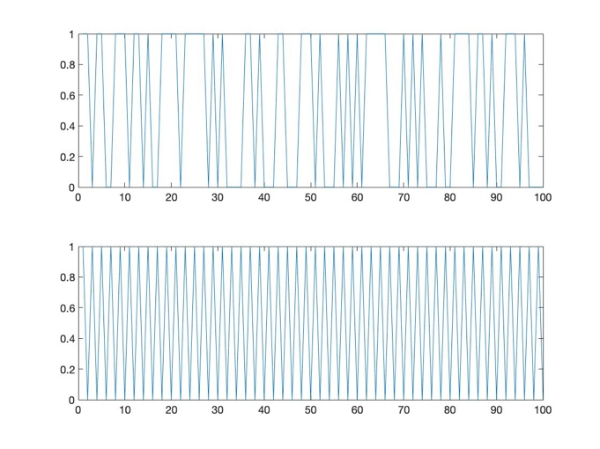

计算结果：regular熵值远小于rand